SAMPLE LETTER / EMAIL TEMPLATE

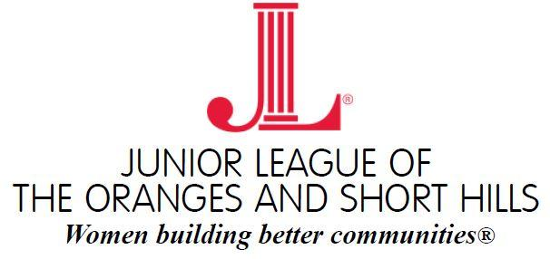

Dear

As a member of the Junior League of the Oranges and Short Hills (JLOSH), I am reaching out to see if [insert school's name / entity's name] would be willing to participate in our annual Thanksgiving Baskets event.

Each year, JLOSH seeks to donate 300 complete Thanksgiving meals with all the trimmings to underserved families of the Orange Public School District. Kings Food Markets has generously committed to donating 300 turkeys; we are seeking your partnership in driving for the remaining Thanksgiving meal items.

Attached please find a flyer that outlines our upcoming event. We are asking that all donated items be collected by November 9, 2018. I, or a representative of JLOSH, will arrange a time to pick up the donated items on this day.

If agreeable, we are asking that [insert school's name / entity’s name] seek donations for one or more of the following:

- boxed mashed potatoes
- boxed stuffing
- canned yams
- canned vegetables (i.e. corn, green beans, peas)
- cranberry sauce
- gravy

Kindly let me know which item(s) your group will be collecting. Thank you for your consideration and we hope that you can partner with us as we work to provide local families in need with a happy Thanksgiving this year.

Thank you.

Junior League of the Oranges and Short Hills (JLOSH) is seeking to donate 300 complete Thanksgiving meals for families in need who have children in the Orange Public School system.
The annual Thanksgiving Baskets Community Program has become a critical safety net for many families who may otherwise not have the means to enjoy a Thanksgiving meal.

We are delighted to partner with JLOSH this Thanksgiving season to ensure that local families
are able to enjoy a Thanksgiving meal complete with all the trimmings. Please help us collect a Thanksgiving side that can be included in the meal baskets that JLOSH will be assembling
and donating. All turkeys are being donated by Kings Food Markets.

WE ARE DRIVING FOR:

____________________________________________________________

We will be collecting donated items up until Friday, November 9, 2018.
Please direct any questions to our local JLOSH contact:

____________________________________________________________

The Junior League of the Oranges and Short Hills is an organization of women developed as civic
and community leaders creating lasting community impact. JLOSH provides service to children living
in East Orange, Livingston, Maplewood, Milburn, Orange, Short Hills, South Orange, Springfield, and
West Orange, and reaches out to women of all races, religions and national origins. Its purpose is exclusively educational and charitable. To learn more about JLOSH, visit www.jlosh.org or find it on Facebook.

Happy Thanksgiving from the Junior League of the Oranges and Short Hills!

